**End-Semester Project Report**

**On**

“**Removal of Tetracycline from Waste Water by the use of graphitic Carbon Nitride”**

By

Abhishek Kumar (Roll No. 21113003)

Mukesh Kumar Ray (Roll No. 21113041)

Prachi Rajput (Roll No. 21113050)

Under the guidance of

Dr. Dharm Pal

(Associate Professor, Dept. of Chemical Engineering, NIT Raipur)



Department of Chemical Engineering

National Institute of Technology, Raipur, C.G. - 492010

**November 2024**

**Department of Chemical Engineering**

**National Institute of Technology Raipur**

**Raipur – 492010, Chhattisgarh, India**

**DECLARATION**

We hereby declare that in the major project work report entitled, “**Synthesis and characterisation of** **orange peel powder incorporated ZnO-chitosan biopolymer nanocomposite”** which is being submitted to National Institute of Technology Raipur for the award of the degree of Bachelor of Technology in Chemical Engineering is a Bonafide report of the work carried out by us under the guidance and supervision of Dr. Dharm Pal, Associate Professor, Department of Chemical Engineering, National Institute of Technology Raipur. We also declare that we have adhered to all principles of academic honesty and integrity and have not misrepresented or fabricated or falsified any idea/data/fact/source in our submission.

**Date: XX**/11/2024

|  |  |  |  |
| --- | --- | --- | --- |
| **S. No** | **Name** | **Roll. No** | **Signature** |
| 1. | Abhishek Kumar | 21113003 |  |
| 2. | Mukesh Kumar Ray | 21113041 |  |
| 3. | Prachi Rajput | 21113050 |  |

**Department of Chemical Engineering**

**National Institute of Technology Raipur**

**Raipur – 492010, Chhattisgarh, India**

**CERTIFICATE**

This is to certify that major project report entitled **“Removal of Tetracycline from Waste Water by the use of graphitic Carbon Nitride”** which is submitted by Abhishek Kumar (211130), Mukesh Kumar Ray (21113042) and Prachi Rajput (21113050) in fulfilment of the requirements for the award of degree of Bachelor of Technology, is a record of the candidates own work carried out by him under my supervision. The matter embodied in this project report is original and has not been submitted elsewhere for the award of any other degree.

**Dr. Dharm Pal**

**Associate Professor**

**Department of Chemical Engineering**

**National Institute of Technology Raipur**

**Department of Chemical Engineering**

**National Institute of Technology Raipur**

**Raipur – 492010, Chhattisgarh, India**

**ACKNOWLEDGMENT**

We would like to express our sincere gratitude to our guide **Dr. Dharm Pal,** Associate Professor Department of Chemical Engineering, NIT Raipur for introducing us into the field of Nanotechnology. We earnestly thank him for his support and guidance that helped us to enhance our knowledge in this field.We extend our sincere thanks to **Dr.** **Amit Keshav**, HOD of Chemical Engineering Department for constant help and encouragement during the entire period of our project.Finally, we show our humble gratitude to the Department of Chemical Engineering, National Institute of Technology Raipur for providing us the opportunity to carry out the project.

**Date:** 25/11/2022

|  |  |  |  |
| --- | --- | --- | --- |
| **S. No** | **Name** | **Roll. No** | **Signature** |
| 1. | Abhishek Kumar | 21113003 |  |
| 2. | Mukesh Kumar Ray | 21113041 |  |
| 3. | Prachi Rajput | 21113050 |  |

Table of Contents

Abstract vi

xxxx vi

1.0 Introduction: 1

2.0 LITERATURE REVIEW: 1

2.1 Tetracycline 1

2.2 Human and Environmental Impact of Tetracycline antibiotics 2

2.3 Originating of Tetracycline in the environment 2

2.4 Removal of Tetracycline 2

2.4.1 Advanced oxidation processes 3

2.4.2 Membrane processes 3

2.5 Physicochemical properties of Tetracycline (TCs) 4

2.5.1 Physical Properties of Tetracycline 4

2.5.2 Chemical Properties of Tetracycline 5

2.6 The tetracycline class of antibiotics 6

2.6.1 Classification of Tetracycline 6

2.6.2 Discovery of Tetracycline 7

3.0 Materials and methods 9

3.1 Materials 9

3.2 Synthesis of materials 9

3.3 Instrumentation 9

3.3.1 XRD 9

3.3.2 FTIR 10

4.0 Photocatalytic Activity 11

5.0 Result and discussion 11

5.1 XRD Analysis 11

5.2 FTIR Analysis 12

6.Conclusion 13

**LIST OF FIGURE**

|  |  |  |
| --- | --- | --- |
| **Fig. No.** | **Name of Table** | **Page No.** |
| 1. |  |  |
| 2. |  |  |
| 3. |  |  |
| 4. |  |  |
| 5. |  |  |

# 

# **Abstract**

The project focuses on the removal of tetracycline pollutants from wastewater using graphitic carbon nitride (g-C₃N₄) nanocomposites as a photocatalyst. Tetracycline, a widely used antibiotic, poses significant environmental risks due to its persistence and potential accumulation in ecosystems, which can lead to adverse effects on human health and ecological balance. Conventional wastewater treatment methods are inadequate for its removal. Our study synthesizes g-C₃N₄-based photocatalysts with different ratios of urea and melamine precursors and evaluates their photocatalytic efficacy in degrading tetracycline under sunlight irradiation. The synthesized photocatalysts were characterized using X-ray diffraction (XRD) and Fourier-transform infrared (FTIR) spectroscopy to determine their structural and functional properties. Photocatalytic performance tests demonstrated that the optimized nanocomposite formulation achieved effective degradation of tetracycline, providing a cost-effective and eco-friendly solution for wastewater treatment. The project highlights the potential of advanced photocatalytic materials to address antibiotic pollution and offers valuable insights into the practical applications of nanotechnology for environmental remediation.

# 1.0 Introduction:

Healthcare was changed by antibiotics, the wonder medications that could fight bacterial illnesses that had once affected humanity. With its introduction, death rates were drastically lowered, and a new era of enhanced world health was ushered in. Worldwide, antibiotics are among the most often used medications. (Takanoğlu, 2024). Antibiotics are a class of medications that are widely used in human and veterinary medicine to treat and prevent disease, as well as to improve feed efficiency and growth rate in the livestock and poultry industries. (Daghrir & Drogui, 2013). Also, Antibiotics have been used as growth promoters because of the need to increase food production due to the exponential growth of the human population in recent years. This has affected the planet's economic capacity and resulted in a shortage of food resources to feed the world's population. Treatment and prevention of bacterial infections was the primary goal of the use of antibiotics in animals raised for human consumption. (Oliveira et al., 2020). These complex chemicals can be natural, synthetic, or semi-synthetic, and they have the power to either kill or stop the metabolism of microbes. The biological agents exhibit antibacterial, antiparasitic, and antifungal properties because of the many functional groups present in their chemical structures. Drugs known as antibiotics are made expressly to treat infections in both people and animals. (Takanoğlu, 2024). The rate of antibiotic consumption increased by 39% and the global consumption of antibiotics by 65% between 2000 and 2015. (Wang et al., 2024)

# 2.0 LITERATURE REVIEW:

## 2.1 Tetracycline

Tetracycline antibiotics have a broad spectrum of action, are highly effective, and are inexpensive, which makes them useful for treating human illnesses, controlling animal diseases, and producing agricultural feed. Tetracycline antibiotics are reportedly the second most often used antibiotics worldwide. High quantities of tetracycline antibiotics can kill a wide range of unusual organisms, including mycoplasma, chlamydia, rickettsia, and Gram-positive and Gram-negative bacteria as well as protozoan parasites. They can also prevent the creation of microbial proteins and are frequently used as veterinary medications for the prevention and treatment of animal farm infections due to their cheaper cost and higher antibacterial action. Antibiotics containing tetracycline are also added to feed to aid with animal growth. (Daghrir & Drogui, 2013)

## 2.2 Human and Environmental Impact of Tetracycline antibiotics

Tetracycline antibiotics are stable and can build up in soil, excrement, water, and the atmosphere, where they can linger for a very long time. Tetracycline antibiotic concentrations in aquatic environments are often expressed in μg·L−1, a level that prevents bacterial growth and organism survival. These substances endanger human health by building up in the human body through the food chain and food web. Antibiotics called tetracyclines have been found in the majority of the foods we eat. Long-term exposure to this substance will slow down the body's metabolism, inhibit the immune system, stop lymphocytes from synthesizing proteins, increase the risk of superinfection, have teratogenic, carcinogenic, and mutagenic effects, and cause joint problems, nephropathy, abnormalities of the central nervous system, endocrine disorders, and other illnesses. [(Takanoğlu, 2024), (Daghrir & Drogui, 2013)]

## 2.3 Originating of Tetracycline in the environment

There are two categories of sources of tetracycline antibiotic residues in water: industrial and residential. Antibiotics similar to tetracycline are hard for organisms (both human and animal) to fully digest and absorb, and between 50 and 80 percent of antibiotics are changed into more harmful metabolites. The primary excretion routes for these metabolites are urine and feces, which invariably results in the presence of antibiotics in home sewage from both urban and rural areas.[ (Takanoğlu, 2024), (Daghrir & Drogui, 2013)] The wastewater from pharmaceuticals is higher in antibiotics than the wastewater from urban homes, indicating that the sewage treatment plants now in use are not able to adequately remove them. Water pollution and ecological balance are caused by the wastewater generated during the pharmaceutical production process and the antibiotic tetracycline, which is not utilized by organisms and ends up in sewage treatment facilities and landfills as raw medications and incomplete metabolites.

## 2.4 Removal of Tetracycline

Antibiotics are ionizable substances that can be neutral or charged (positive or negative) in the natural world. Antibiotics have distinct processes for absorption and breakdown in soil due to their distinct chemical characteristics. The rate of breakdown of these chemicals in nature is influenced by a variety of biotic and abiotic variables. As a result, each antibiotic molecule in the soil has a unique half-life and breakdown process. (Takanoğlu, 2024). Unfortunately, tetracycline cannot be removed by traditional method. Therefore, in the water environment, the treatment technologies used to remove tetracycline antibiotics include adsorption; biological, physical and chemical methods; advanced oxidation; and the comprehensive treatment technologies used in sewage plants.

### 2.4.1 Advanced oxidation processes

Advanced oxidation processes, or A.O.Ps, involve using heterogeneous photocatalysis to completely oxidize both organic and inorganic materials. Organic molecules were degradable in photocatalytic oxidation when oxidizing agents such as oxygen, light, and semi-conductor were present. Zinc oxide is a great photocatalytic oxidant for a variety of pollutants found in wastewater, including waste from pharmacies, printing and dyeing processes, and paper manufacturing. Zinc oxide (ZnO) has been acknowledged as a heterogeneous photocatalyst and has exhibited the ability to degrade organic composites using aqueous techniques. The primary challenge with this material is the need for high photocatalyst loadings and the time-consuming, expensive ZnO retrieval process. (Aljeboree et al., 2020)

**2.4.1.1 Photocatalysis**

There are two types of this process: direct (the light irradiation itself will break down the antibiotics) and indirect (the light irradiation on the catalyst will release free radicals, which will mediate the degradation process). It is the application of a natural or simulated light source on the catalyst for the complete degradation of antibiotics. photolysis. the photodeamination of TC upon interaction with molecular oxygen species, as demonstrated by the first photochemical oxidation of TC in 1979. For the elimination of TC, this method results in several UV-based photodegradations. When H2O2 is added to TC during UV treatment, the quantum yield may be enhanced. Additionally, the combination of UV and H2O2 results in a lower TOC content and less acute toxicity from TC-degraded byproducts. (Gopal et al., 2020)

### 2.4.2 Membrane processes

Membrane processes include reverse osmosis, nanofiltration, and ultrafiltration. One membrane technique that has been frequently employed in conjunction with nanofiltration (or ultrafiltration) to eliminate tetracycline antibiotics is reverse osmosis. Reverse osmosis/ultrafiltration or reverse osmosis/nanofiltration techniques were used to remove oxytetracycline. For instance, these investigations showed that the reverse osmosis/ultrafiltration technology is thought to be a useful way to get rid of oxytetracycline from wastewater used in pharmaceutical manufacturing. In contrast, the use of nanofiltration technology to distilled water tainted with calcium chloride, humic acid, and NaCl eliminated 50–80% of the tetracycline antibiotics. Reverse osmosis, nanofiltration, and ultrafiltration methods, however, are highly sensitive to the concentration of dissolved salts and the amounts of organic material that naturally occur in the water matrices. Fouling of the membrane may result from these substances being present in water at higher concentrations. (Daghrir & Drogui, 2013)

## 

## 2.5 Physicochemical properties of Tetracycline (TCs)

### 2.5.1 Physical Properties of Tetracycline

Table 1. Physical Properties of Tetracycline

|  |  |
| --- | --- |
| Chemical Structure: | Figure 1. Chemical Structure of Tetracycline[6] |
| Molecular Formula: | C22H24N2O8 |
| Molecular weight: | 444.4 g/mol[8] |
| Color/Form: | Yellow/ Crystalline Powder[8] |
| Solubility: | 231 mg/L (at 25oC)[8] |
| Melting Point: | 172.5oC [8] |
| Optical Activity: | Yes [8] |
| pH: | 3 – 7 (at saturated solution)[8] |

### 2.5.2 Chemical Properties of Tetracycline

Because of their distinctive structural components—hydroxyls, dimethylamino substituents, and the conjugated keto-enolic system—tetracyclines are amphoteric molecules. Tetracyclines react to create salts with bases or acids. Tetracyclines are most frequently employed in pharmaceutical formulations as HCl salts (e.g., eravacycline, sarecycline).(Rusu & Buta, 2021)

**Acidic Condition :** Tetracycline dehydrates to produce anhydrotetracycline when it is subjected to diluted acid conditions. Further cleavage and lactonization of anhydroterramycin results in apoterramycin: [9]

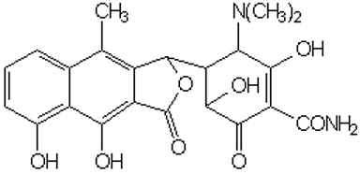

Figure 2. Anhydrotetracycline

**Basic Condition :** Tetracycline's 11a carbon is attacked by a mild alkali, converting it to isotetracycline: [9]

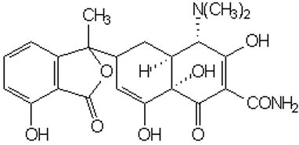

Figure 3. Isotetracycline

**Formation of complexes :** Tetracycline's B- and C-ring oxygen atoms give it a strong propensity to form complexes with a wide range of chemical species:

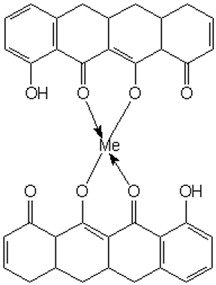

Figure 4. Tetracycline forming complexe

The metal ions, phosphates, citrates, salicylates, p-hydroxybenzoates, saccharin anion, caffiene, urea, thiourea, polivinylpyrrolidone, serum albumin, lipoproteins, globulins, and RNA are the ones with which it forms complexes the most easily: Fe3+, Fe2+, Cu2+, Ni2+, Co2+, Zn2+, Mn2+, Mg2+, Ca2+, Be2+, and Al3+.[9]

## 2.6 The tetracycline class of antibiotics

### 2.6.1 Classification of Tetracycline

Historically, tetracyclines are considered First generation if they are obtained by biosynthesis such as: Tetracycline, Chlortetecycline, Oxytetracycline, Demeclocycline. Second generation if they are derivatives of semi-synthesis such as: Doxycycline, Lymecycline, Meclocycline, Methacycline, Minocycline, Rolitetracycline. Third generation if they are obtained from total synthesis such as: Tigecycline, Omadacycline, Sarecycline Eravacycline. However, some researchers consider Tigecycline to be distinct from other tetracyclines drugs and are considered as a new family of antibacterials called Glycylcyclines. (Fuoco, 2012)

Table 2. Classification of Tetracycline in terms of generation.

|  |  |  |
| --- | --- | --- |
| Generation | Method of Obtaining | Representatives |
| First generation | Biosynthesis | Chlortetecycline, Oxytetracycline, Demeclocycline |
| Second generation | Semi-synthesis | Doxycycline, Lymecycline, Meclocycline, Methacycline, Minocycline, Rolitetracycline |
| Third generation | Total-synthesis | Tigecycline, Omadacycline, Sarecycline Eravacycline |

### 2.6.2 Discovery of Tetracycline

Scientists' interest in creating novel tetracyclines has once again increased due to the rising prevalence of antibiotic-resistant microorganisms. In order to reevaluate the compounds that had already been synthesized and create new ones that could be categorized into a third generation, the programs were reopened at the end of the 1980s. The alteration of the D ring's C7 and C9 locations in the sancycline structure was of primary importance. By following these procedures, a novel class of C9-aminotetracyclines with a glycyl moiety called as glycylcycline has been discovered. Rusu and Buta 2021)

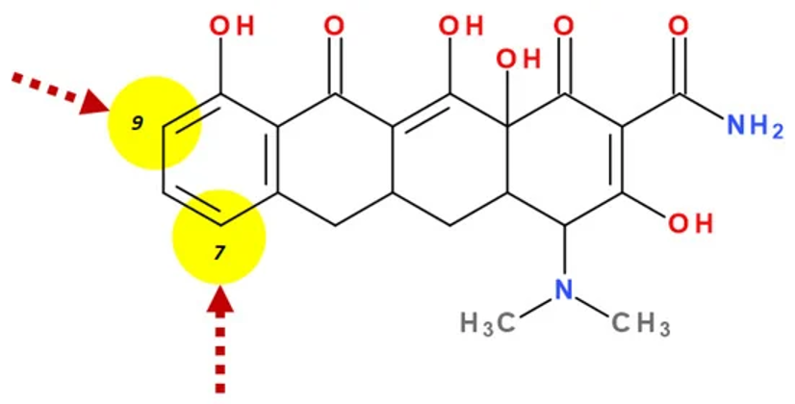

Figure 4. Chemical Structure of Sancycline. Rusu and Buta 2021)

The derivatives of modern tetracyclines include glycylglicine (tigecycline), aminomethylcycline (omadacycline), fluorocycline (eravacycline), and a 7-[(methoxy-(methyl)-amino)-methyl]methyl] derivative (sarecycline) that have essentially identical chemical structures. (Rusu and Buta 2021)

A synthetic version of minocycline was identified in 1993 and is called tigecycline. After more than 30 years, tigecycline was the first tetracycline to be used in therapy. As a result, tigecycline may serve as the model for a brand-new tetracycline subclass. The advantage of this new tetracycline is that it is more potent than multidrug-resistant Gram-positive and Gram-negative bacteria. Under the trade name Tygacil, tigecycline was discovered by Wyeth Pharmaceuticals Inc. and approved by the FDA in 2005 and the European Medicine Agency (EMA) in 2006. Complicated skin and soft tissue infections as well as complex intra-abdominal infections are approved uses for tygacil. Similarly, tigecycline's usage for the treatment of community-acquired pneumonia was approved by the FDA in 2008. After the product was introduced to the market, research was conducted on a number of other uses, including nosocomial pneumonia, diabetic foot infections, nosocomial urinary tract infections, nosocomial MDR pathogens, and Clostridium difficile infections. Due to its low absorption, tigecycline must only be used parenterally, which is a drawback.[ Rusu and Buta 2021)

One of the most recent and well-liked tetracyclines, omadacycline is the first member of the aminomethylcycline subclass. Its wide range of activity has been demonstrated in vitro against anaerobic, atypical, and Gram-positive and Gram-negative bacteria. Furthermore, this drug exhibits action against vancomycin-resistant enterococci, penicillin-resistant, MDR Streptococcus pneumoniae, and methicillin-resistant Staphylococcus aureus (MRSA). Omadacycline is available for parenteral and oral administration, unlike tigecycline. The FDA authorized both versions in 2018 for the treatment of community-acquired pneumonia, complex skin and soft tissue infections, and complicated intra-abdominal infections. Omadacycline is now being studied in phase II clinical studies to treat urinary tract infections, including cystitis and acute pyelonephritis. In the US, the medication Nuzyra received approval for use.(Rusu & Buta, 2021)

The synthetic fluorocycline eravacycline is produced using complete synthesis and has the fundamental chemical structure of the tetracyclines class. Furthermore, certain alterations were implemented on the naphtacen nucleus' D ring. Its extraordinary efficacy against both Gram-positive and Gram-negative bacteria that have acquired particular resistance mechanisms to the tetracycline antibiotic class is a result of these chemical optimizations, and it is used to treat difficult adult intra-abdominal infections. It is accessible for parenteral administration in the USA and numerous European nations. Rusu and Buta 2021)

An analog of tetracycline created especially to treat acne is sarecycline. For the treatment of inflammatory lesions associated with moderate to severe non-nodular acne vulgaris, it is offered as an oral formulation. When compared to earlier tetracyclines (minocycline and doxycycline) used in acne therapy, the primary benefit of this novel tetracycline is its stronger selective activity against Cutinebacterium acnes. Compared to minocycline and doxycycline, the likelihood of developing antibiotic resistance is reduced because of this selectivity. Allergan and Paratek Pharmaceuticals created serendecycline, which Almirall S.A. later purchased by acquiring the dermatological portfolio. In 2018, the FDA authorized sarecycline under the brand name Seysara.[ Rusu and Buta 2021).

# 3.0 Materials and methods

## 3.1 Materials

We obtained a variety of materials from reliable sources to support our research activities for the current study. The materials used in this study included Urea and Melamine. The Urea (H2NCONH2, 99% extra pure grade) was obtained from Loba Chemie Private limited, a renowned supplier of high-purity chemicals and biochemicals. The Melamine (C3H6N6, extra pure grade) was obtained from Loba Chemie Private limited, a renowned supplier of high-purity chemicals and biochemicals.

## 3.2 Synthesis of materials

Three samples were prepared using varying ratios of urea and melamine. For sample 1, urea and melamine were combined in a 1:1 ratio. After thoroughly mixing the components, the sample was crushed and then heated in a muffle furnace at 540°C for four hours. Upon cooling, the sample was crushed again before being sent for testing. Following the same process, additional samples were prepared with urea-to-melamine ratios of 1:2 and 2:1, respectively.

## 3.3 Instrumentation

### 3.3.1 XRD

X-ray diffraction (XRD) is a powerful technique widely used to explore and understand the crystalline structure of materials. When a beam of X-rays strikes a crystalline sample, the atoms within the crystal lattice cause the X-rays to diffract in specific directions. This diffraction pattern is unique to the atomic arrangement in the crystal, much like a fingerprint for that structure. The XRD pattern thus provides a detailed insight into the crystal’s atomic structure, and from it, we can infer essential characteristics like the arrangement and spacing of atoms. The diffraction pattern results from constructive interference between X-rays scattered by atoms within various crystallographic planes of the crystal.

In the setup you described, a PANalytical X’pert Powder X-ray diffractometer is used with Cu Kα radiation, which has a wavelength of 1.541 Å. The choice of this wavelength is significant because it matches well with the typical atomic distances in crystalline materials, enhancing the diffraction effect. Scanning across a 2 Theta range of 10° to 80° allows the capture of multiple diffraction peaks, each corresponding to a different set of atomic planes. From this pattern, various structural details can be deduced. For instance, the positions and intensities of these peaks are characteristic of specific crystalline phases, allowing phase identification. Additionally, the breadth of each peak can reveal the crystallite size: narrower peaks often indicate larger crystalline domains, while broader peaks suggest smaller domains, which can indicate nanocrystalline or amorphous structures. This information is crucial for materials characterization, as it reveals the composition, structure, and sometimes even the level of crystallinity or purity of a sample.

### 3.3.2 FTIR

Fourier-transform infrared (FTIR) spectroscopy, on the other hand, is a technique used to probe the molecular structure and functional groups within a sample. This technique operates on the principle that different molecular bonds and functional groups absorb infrared light at specific frequencies. When infrared radiation passes through a sample, molecules within the material selectively absorb energy at frequencies corresponding to their vibrational modes, resulting in a spectrum that acts as a molecular "fingerprint" of the material. In your setup, an Alpha 2 FTIR model by Bruker is used. FTIR works by recording an interference pattern as infrared light passes through the sample, which is then transformed mathematically into an absorbance spectrum using Fourier transform algorithms.

This FTIR spectrum provides valuable information about the types of chemical bonds present. For example, peaks in specific regions can indicate the presence of functional groups like -OH, -COOH, or -NH2. The positions and intensities of these peaks are characteristic of certain molecular structures, making FTIR a valuable tool for identifying organic compounds and assessing chemical modifications. Together, FTIR and XRD provide complementary insights into both the atomic and molecular makeup of materials, enabling a thorough understanding of their structure and properties.

# 4.0 Photocatalytic Activity

In our study, we thoroughly investigated the photocatalytic performance of materials synthesized using urea-to-melamine ratios of 1:1, 1:2, and 2:1, aiming to understand how these ratios influence photocatalytic efficiency. The experiments focused on degrading tetracycline hydrochloride (TCH) under sunlight irradiation to assess each catalyst's effectiveness. Specifically, 0.02 g of each photocatalyst was dispersed into a 50 ml solution of TCH (10 mg/L), prepared with Millipore water to ensure purity. To allow the system to reach an adsorption-desorption equilibrium, this mixture was stirred magnetically in the dark for 30 minutes, an essential step to balance adsorption effects before initiating the photodegradation process.

After achieving equilibrium, the suspension was exposed to sunlight, and the degradation of TCH was monitored by measuring the concentration at 15-minute intervals using a UV-Vis spectrophotometer. The analysis focused on the peak absorbance at 359 nm, which was verified in preliminary tests as the highest absorbance wavelength for pure TCH, thus providing a reliable indicator for tracking concentration changes. Over time, as TCH degraded, the decrease in absorbance at 359 nm indicated the effectiveness of the photocatalyst.

Once each experiment concluded, the photocatalyst was recovered by centrifuging the solution at 8000 rpm, thoroughly rinsed with distilled water, and then dried at 105°C in a heating oven for 4 hours. This procedure enabled the recycled photocatalyst to be used in subsequent stability and reusability tests, ensuring comprehensive performance evaluation. A blank degradation experiment without any photocatalyst was also conducted under identical conditions to establish a control, providing a baseline for the natural degradation of TCH under sunlight. This detailed approach allowed us to systematically assess the impact of urea-to-melamine ratios on photocatalytic degradation efficiency.

# 5.0 Result and discussion

## 5.1 XRD Analysis

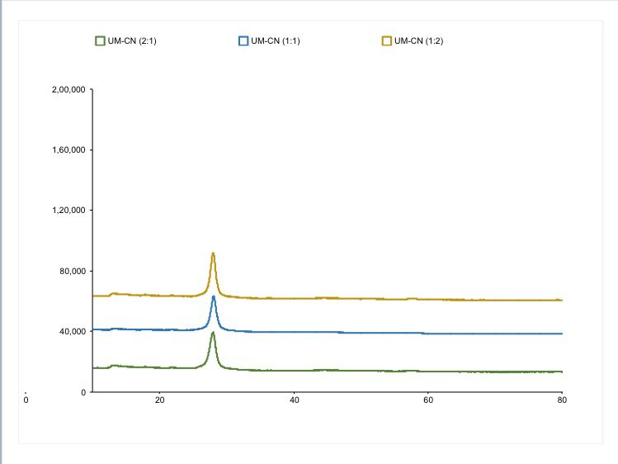

Figure 5. Powered XRD Analysis of UM-CN(2:1), UM-CN(1:1), UM-CN(1:2)

This XRD graph shows diffraction patterns for three samples with different UM-CN ratios: (2:1), (1:1), and (1:2). The x-axis is the 2θ angle, and the y-axis is the intensity of diffracted X-rays. Each sample has a peak around 20-30 degrees, indicating crystalline phases. "UM-CN (1:2)" has the highest peak intensity, suggesting it has the most crystalline structure among the samples. The change in intensity reflects how composition affects crystallinity.

## 5.2 FTIR Analysis



Figure 6. FTIR spectra of UM-CN(2:1), UM-CN(1:1), UM-CN(1:2)

This XRD graph shows diffraction patterns for three samples with different UM-CN ratios: (2:1), (1:1), and (1:2). The x-axis is the 2θ angle, and the y-axis is the intensity of diffracted X-rays. Each sample has a peak around 20-30 degrees, indicating crystalline phases. "UM-CN (1:2)" has the highest peak intensity, suggesting it has the most crystalline structure among the samples. The change in intensity reflects how composition affects crystallinity.

# 6.Conclusion

The XRD and FTIR analyses reveal the influence of UM-CN ratios on the crystallinity and chemical structure of the samples. XRD results show that the "UM-CN (1:2)" sample exhibits the highest peak intensity, suggesting it possesses the most crystalline structure among the three ratios. The FTIR analysis highlights distinct molecular bond vibrations within the 500-1500 cm⁻¹ range, indicating variations in chemical composition and bond structure based on the UM-CN ratio. Together, these results suggest that adjusting the UM-CN ratio significantly impacts both the crystallinity and molecular structure of the samples.

References

Aljeboree, A. M., Abdulrazzak, F. H., Alqaragoly, M. B., Karam, F. F., Alkaim, A. F., & Hussein, F. H. (2020). Photocatalytic of pharmaceutical tetracycline (TCS) by zinc oxide (ZnO). *Journal of Critical Reviews*, *7*(7), 960–962. <https://doi.org/10.31838/jcr.07.07.174>

Daghrir, R., & Drogui, P. (2013). Tetracycline antibiotics in the environment: A review. *Environmental Chemistry Letters*, *11*(3), 209–227. <https://doi.org/10.1007/s10311-013-0404-8>

Fuoco, D. (2012). Classification framework and chemical biology of Tetracycline-structure-based drugs. *Antibiotics*, *1*, 1–13. <https://doi.org/10.3390/antibiotics1010001>

Gopal, G., Alex, S. A., Chandrasekaran, N., & Mukherjee, A. (2020). A review on tetracycline removal from aqueous systems by advanced treatment techniques. *RSC Advances*, *10*(45), 27081–27095. <https://doi.org/10.1039/d0ra04264a>

Oliveira, N. A., Gonçalves, B. L., Lee, S. H., Oliveira, C. A. F., & Corassin, C. H. (2020). Use of antibiotics in animal production and its impact on human health. *Journal of Food Chemistry and Nanotechnology*, *6*(1), 40–47. <https://doi.org/10.17756/jfcn.2020-082>

Rusu, A., & Buta, E. L. (2021). The development of third-generation tetracycline antibiotics and new perspectives. *Pharmaceutics*, *13*(12). <https://doi.org/10.3390/pharmaceutics13122085>

Takanoğlu, D. (2024). *Antibiotics : environmental impact and degradation techniques*. *4*(2), 684–698.

Wang, F., Wang, Z., Zhao, Y., & Zhang, J. (2024). Performance of Traditional and Emerging Water-Treatment Technologies in the Removal of Tetracycline Antibiotics. *Catalysts*, *14*(4). <https://doi.org/10.3390/catal14040269>